ROV Assembly

Mechanical ROV
3D printing procedures:

– RPS
–FEDC

Bassplate
- Sliced into 4 pieces

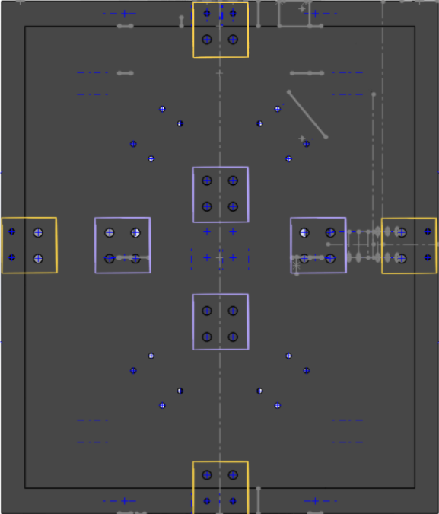
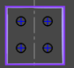
6.35 mm screws (¼ inch)
6.35 mm nuts

Required:
4 x Aluminum 6061 brackets -> Laser cut

Chassis
- Chassis + Bassplate

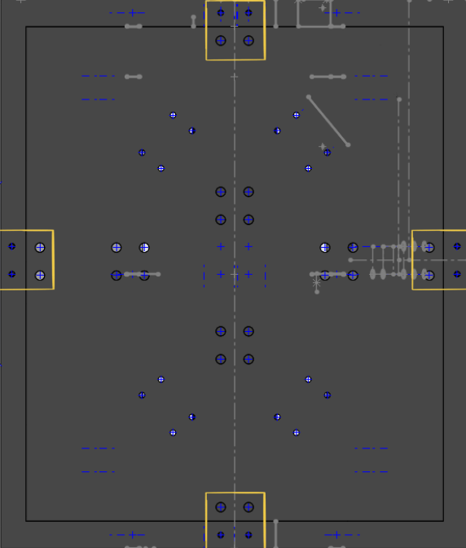

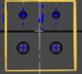

Required:
4 x Aluminum 6061 brackets -> Laser cut

Top side
M3-18mm screws
M3 heated inserts
Bottom side
6.35 mm screws (¼ inch)
6.35 mm nuts

Electronics Enclosure Platform:
- Slice the Electronics Enclosure Platform and utilize the PLA
  - ROV Electronics Tray for 4" Tube

Polyurethane Potting:
- 2 part potting compound, 2:1 mix ratio
- 5-7 minute working time
- Pour into component
- 24 hour cure at room temperature
- Constant service temperature of -50 to 120 °C (-58 to 248 °F)
Thrusters
- Mesh
  - 3D printed using PETG
  - Attached to thrusters on both sides using a clamping mechanism (or using other methods such as epoxy, superglue, etc.)
- Thrusters
  - Will need to use plates (vertical) or brackets (horizontal) to mount the thrusters
  - 80 Heat set inserts in total are needed to mount the thrusters
    - The heat set inserts will be testing on a singular mount before attaching to the chassis to make sure it provides a secure connection. The length provides 2mm of secure fit at the base, and the inserts are applied through the back and are multidirectional.
  - M4 screws are provided with the thrusters, and extra screws were purchased.

Float Assembly

Mechanical
Hull:
- Drill holes in the hull for two sensors on the end cap and two openings for the ballast pump. Total of 4 holes.
  - Ultrasonic sensor hole dimensions:
  - Depth sensor hole dimensions:
  - Ballast hole dimensions:
- Drill small holes (not through) into the top end cap
  - Hole dimensions:
- Epoxy the recovery feature into the end cap holes
- Cut foam into a cylindrical shape, drill holes, then hollow out the inside. (alternatively, cut foam flat to the correct thickness, drill holes, then form it to the inside of the hull).
  - Foam thickness:
  - Hole dimensions same diameters as hull holes
- Epoxy zinc weight to the bottom end-cap
- Epoxy electronics harness to the top end-cap
- Polyurethane-pot the sensors into the end-cap holes
- Apply the heating pad to the underside of the electronics harness

Zinc weight procedures:
- Weigh total system mass (expecting to be slightly too heavy), then drill small holes into the zinc until we are exactly neutrally buoyant.

Electronics harness procedures:
- Lathe diameter to size
- Mill side openings
- Lathe inner diameter to size
- Saw off excess length
- Face the sawed-off side using the lathe facing tool

Ballast:
- Peristaltic Pump will be installed within the float enclosure
- Holes for the intake and exhaust tubes will need to be drilled into the enclosure
  - Waterproofing will be needed to the tubes
- Exhaust tube will be connected to the bag, intake tube will be secured to the bottom of the pump
  - Water bag will be secured to the bottom of the float
    - Will need to either print a bracket to hold, zip tie the bag, or glue to to the hull

Electrical

Ground Station Assembly

